* If we go to **/etc/ansible**. We can find **ansible.cfg** and hosts and roles files
* Host file is our inventory file. We can use this or create another one by copying the current one
* **“ansible.cfg”** is the configuration file that contains the default data such as path of host file, remote node server port etc.

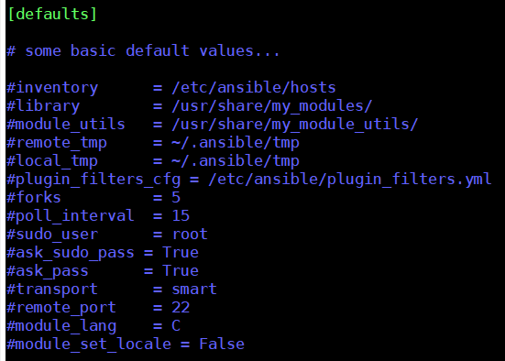

**Adding hosts in inventory:**

* We can add private ips of the machines as below at the end of file and save it
* We can add all the node’s private DNS here. We can also add ip addresses if we want



* We can use below ping module to check that
* **Ansible -m ping all (to ping all)**
* To make the ping works, we need to enable the ICMP (which is used for ping and doesn’t contains any port) in security group inbound rules as below. We can also enable all traffic.

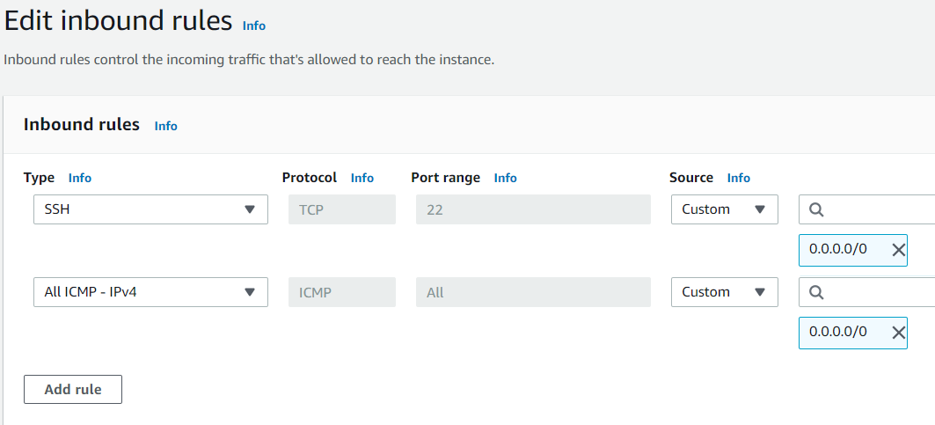

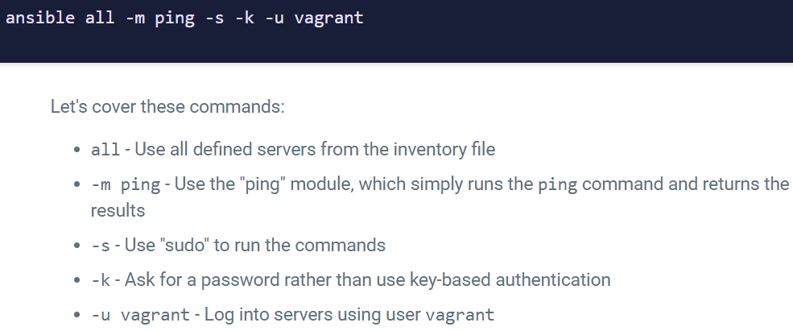

**Grouping the servers:**

* What is we have 4 nodes, two are web server and two are db servers. There might be some situations we need to perform tasks particularly on DB server or web server. To do such things we have grouping. We can group our nodes
* We can create groups in hosts file as below. We need to write something in square brackets for grouping as below

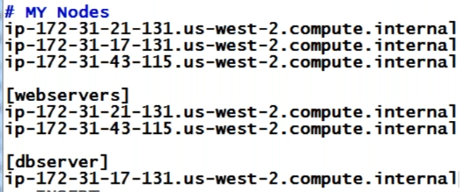

* We can create groups like whatever we want. We may group based on OS etc.
* A machine can be part of different groups also
* If machine is part of no group. Then it is ungrouped machine
* If we want to restart all redhat servers. Then we need to create a group with all redhat servers and find a module for that. Then execute it
* Always better to keep machine at least part of one group. So that we don’t need to use the whole machine name every time
* Only local host will not be part of any group
* If we have added localhost then we need to add ssh key to the local machine also
* Once we add the servers into groups, we can all the servers with group name or we can also call them separately.
* **ansible -m ping <group_name>**

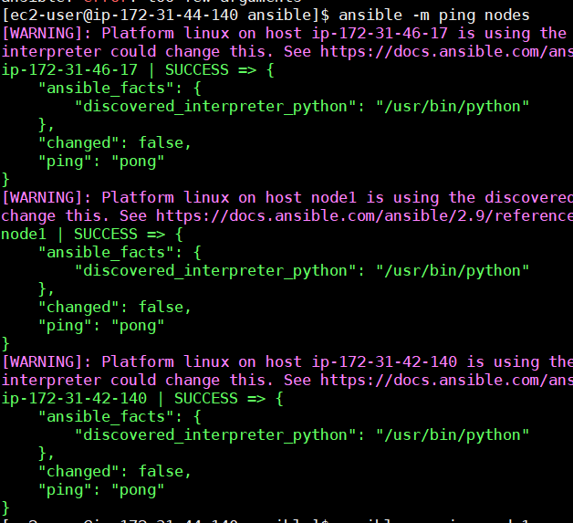

**Defining port:**

* We can give the port in hosts file other than default as below.



**Adding host alias name:**

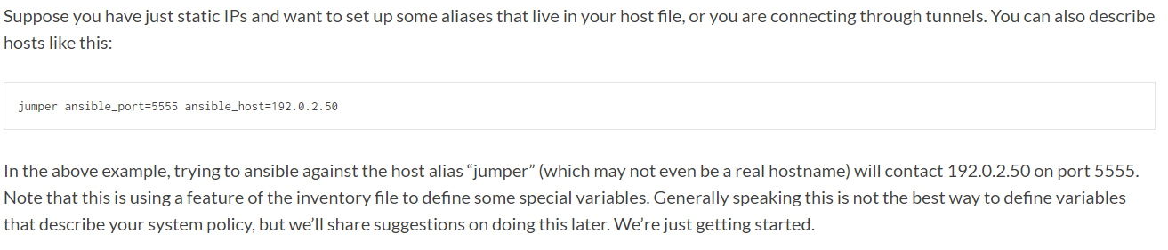

* When we use this alias name with the friendly name, we should pass atleast “ansible_host” variable along with that so that ansible will know what the exact hostname is as below.

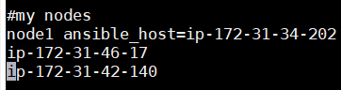

**Now, we can call that host with the alias name but can not with the actual host also**

* **ansible -m ping node1**

we need to use these alias names while adding it to the groups as below.

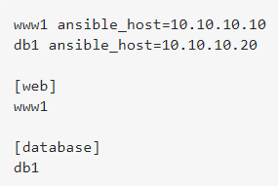

* We can also add as below.

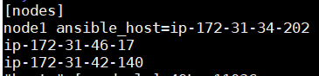

**Adding lots of hosts:**

* If we have multiple servers with same range. We can follow below method instead of adding all of them on by one.

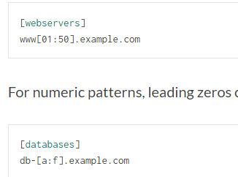

**Note:**

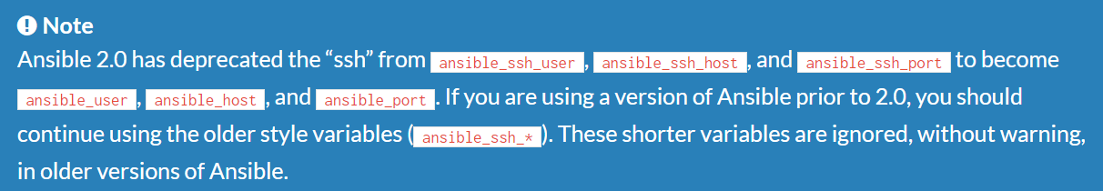

**Connection type and username:**

* We can also add the connection type and username in hosts file as below.

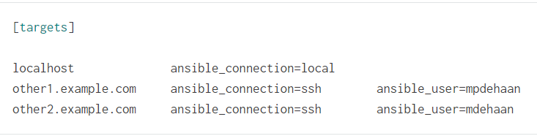

**Host variables:**

* We can also add some variable to hosts which can be used later in playbooks.

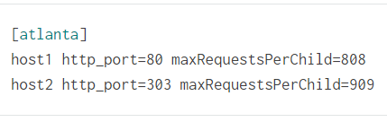

**Group variables:**

* Variables can be applied to whole group at once.

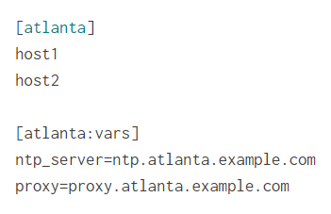

**Groups of groups:**

* It is also possible to create a group with multiple groups with “children” and assign the variable as below.

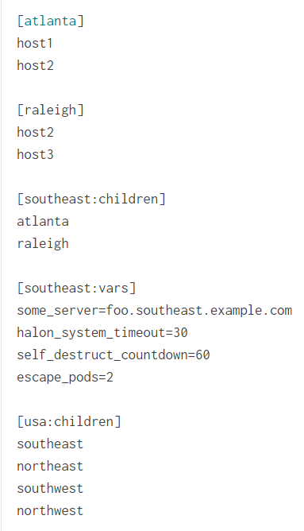

**Examples:**

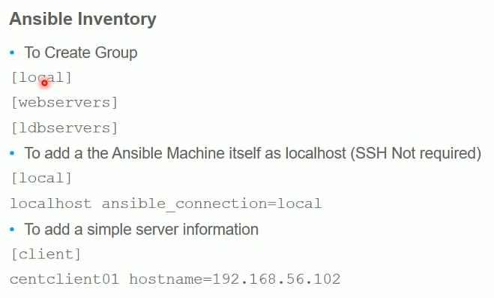

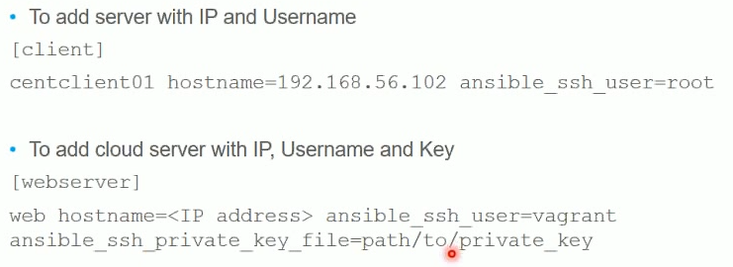

* We may also enable ssh connection as above
* Also, we can specify any remote ip, username and the path to the key

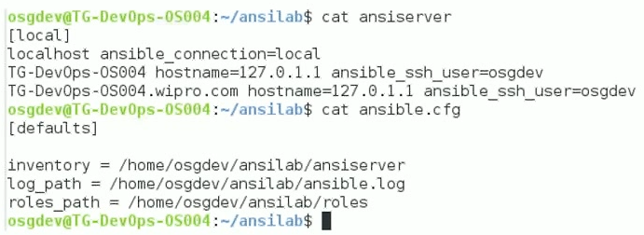

**If we give ansible_ssh_user, it will allow to access only that user**

**Inventory parameters:**

**Ansible connection:**

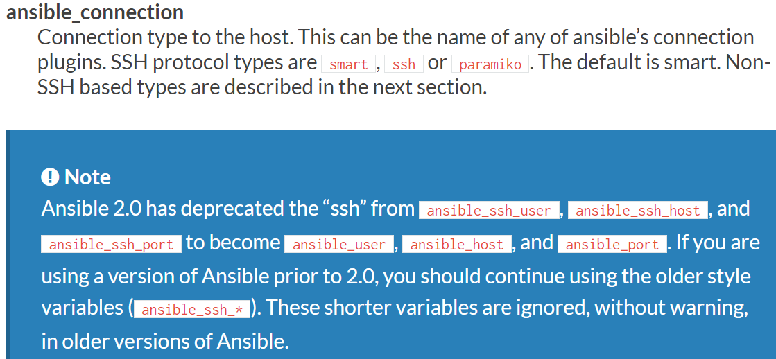

**SSH connection:**

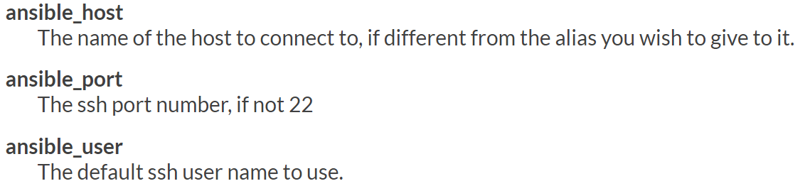

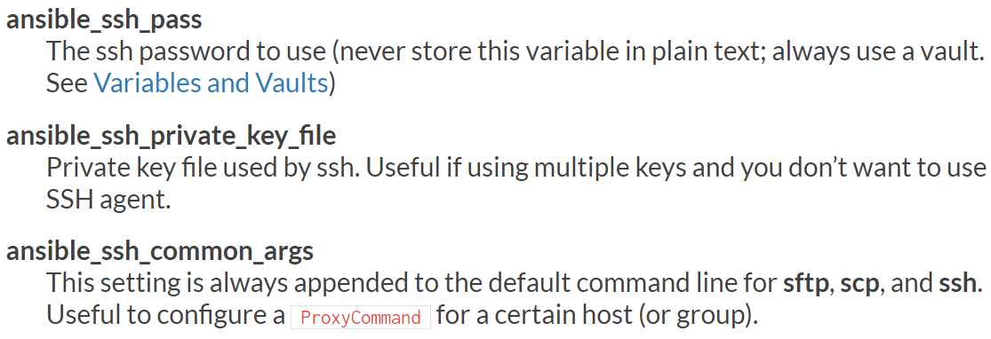

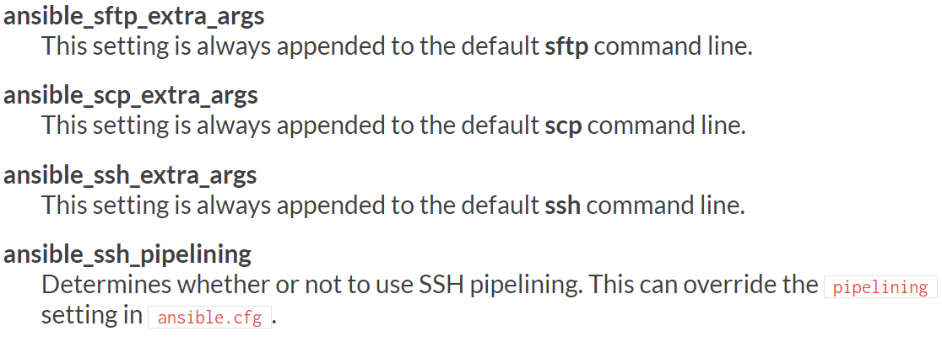

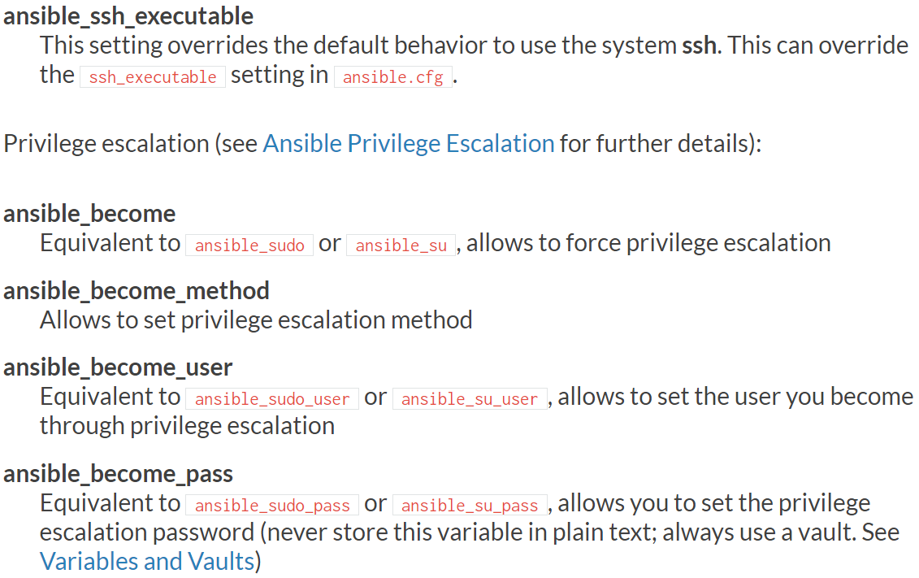

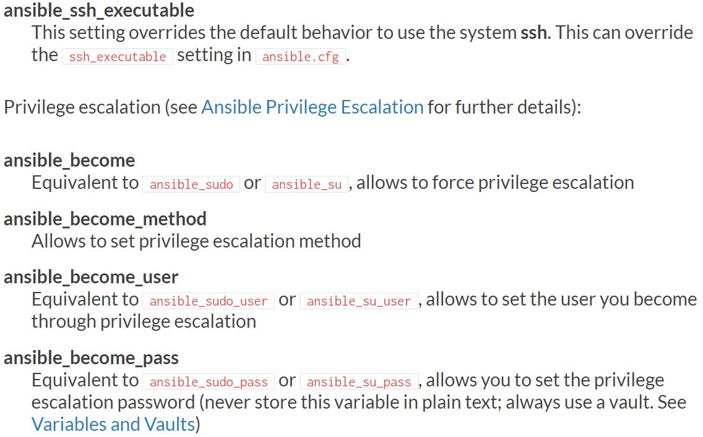

**Changing the hosts file path:**

* We can create own configuration file and set it up as below

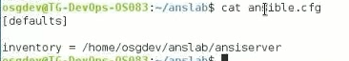

* We need to run ansible command from the inventory file location. Otherwise, it won’t work

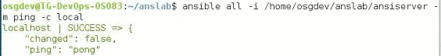

* Use **“-I”** if the hosts file location is different
* If host file and conf file in same location and we are using ansible from same location. Then no need to use **-i**
* If we don’t give -i in the command, it will pick the default hosts file from /etc/ansible/hosts
* **Ansible -m ping -i <path of file> all**
* Static inventory means the list which we write
* If we have 1000 server. We can go for dynamic inventory which is not required to write down all the list manually
* Dynamic list is where we can give ansible an executable. It can be python file or shell script which returns the inventories in json format
* Rather than writing static list we can give the link to a program
* We write static list in /etc/ansible/hosts. But if it is dynamic, it will be a program or a script. Command line won’t change